**Mission:**

Our mission is to improve the state system of care for mental health and substance use challenges by magnifying the voice of the individuals with lived experience and their families, and by making specific recommendations for improvements as required by federal and state statutes. Federal Title 42 § 300x–3, State Title 34-B §3609

**Vision:**

The QIC wants every person in Maine to have access to the highest quality mental health and substance use services in an environment of respect and empowerment.

**Values:**

1**.** We are focused on improving the system as a whole (the mental health and substance use disorder system).

2. We believe in equal access to a fair system of high-quality services.

3. We respect all individuals.

4. We value diversity, equity, inclusion, and accessibility.

5. We value input from all stakeholders.

6. We are especially interested in hearing, amplifying and acting on the voices of those with lived experiences and their families.

7. We earn trust through demonstrating integrity, passion, and commitment to all of our work.

Welcome, Announcements, Adjustments to the Agenda (9:00-9:05)(5 mins)

In Attendance:

|  |  |  |
| --- | --- | --- |
| ~~Ariel Linet~~ | ~~Jessica Wood~~ | **Richard Ladd, Sr** |
| ~~Bill Lowenstein~~ | **Joel Gilbert** | ~~Robin Levesque~~ |
| **Bobbi-Jo Bechard** | **Katherine Temple** | **Sarah Ferguson** |
| **Brianne Masselli** | ~~Liz Remillard~~ | ~~Sharon Jordan~~ |
| **Christina Hardy** | **Liz Wing** | **Stephanie Farquhar** |
| **Diane Bouffard** | **Malory Shaughnessy** | **Susan Parks** |
| **Gabrielle Gallucci** | ~~Michael Freysinger~~ | **Vickie McCarty** |
| **Jeff Tiner** | **Narissa Seamans** | ~~Virginia Jewell~~ |
|  | **Polly Finlay** |  |
|  |  |  |

(9:05-11:00) (115 mins)

Input to the Block Grant application

The block grant received a slight increase in Feb of $288,000. SAMSHA dictated it goes toward Evidence Based Practices for crisis, to train up providers, and work with schools. This is one time money only for 2 years.

Substance Use Disorders Commission is oversight for SUD. This document asks about integration. State is submitting 2 separate applications, one for QIC and one for SUD.

Many QIC members, for their agency work, have attended stakeholder meetings, provided testimony, participated in bills, letters of support.

Bill attends all and Diane some of the SUD Committee meetings.

Impact of the revision of the MH rights of recipients, and QIC members go to stakeholder sessions, CCBHC work, QIC members have open invitations.

Highlight guest speakers: CDC with Youth Mental Health Survey, OMS, CCBHC initiative

Strategic planning work is a big focus this cycle, working on membership and increasing capacity.

How is QIC working with BIPOC community? – we added diversity, equity, inclusion, and accessibility to our vision.

Application

2. Prior to implementation the state does a number of listening sessions for different audiences. Strategic planning process. RFPs. Grant contracts to fund uninsured. The Dept finances conferences and receives feedback there. Crisis Community Access System listening groups. Meet with Adult advocacy services. Look to advocacy organizations to keep DHHS informed. Community listening and 1-1 listening sessions. Push out information on DHHS Office listservs, and distribution lists of agency partners. Posters and flyers through contracted providers. MH rights of recipients work with DRM. (Many of people we serve don’t have access to computers, we should look into other ways to get the information out). Exit surveys for consumers. Beginning to add in exit surveys from crisis. Individual follow- up is also beginning. Funding free CCAR training for recovery coaches, free trainings - for children providers - RUBI, PPP. OBH lists all the trainings they provide, so QIC doesn’t need to list them all.

3. no

4. no – we should have more youth. We have made an effort to bring in young adults. And every facet of representation. A lot of people don’t know that the QIC exists. There should be a way to inform people about it. Put a place on the website for feedback – struggles and positive notes. (put this in #6) JBS international serving specific for Councils. Could learn from other states. Could we have staff that work with youth do outreach? Intergenerational listening sessions, (texting). Many agencies have youth groups.

5. The QIC is trying to beef up social media, a place for website to gather input. Note our plans for the next 2 year stretch. Note that before COVID held meetings. Note all the things we participate in previously mentioned. And how do we expand that. Reference strategic planning is focused on outreach and education. Brochures placed in strategic places.

Maybe create a form to fill out monthly about what activities each individual did for QIC. Sarah said she would.

6. From above, job descriptions, help with who are we/ what do we do/ how do we connect with people in the state, new manual about how to establish a great advisory council, aligning ourselves with new best practice standards – over several months,

Maine QIC has been trying to collaborate with VT. & NH

Link to: [Maine Community Mental Health Services Block Grant Application FY 2022/2023 (submitted 9/1/21) (PDF)](https://www.maine.gov/dhhs/sites/maine.gov.dhhs/files/inline-files/MHBGFY22_WebBGAS-submission_08-31-21.pdf) 09/02/2021

Link to Google Form for **QIC – Monthly Updates** to activities outside of QIC monthly meetings. <https://forms.gle/ieaoZ18dhqUqwV718>

Respectfully submitted,

Sarah Ferguson

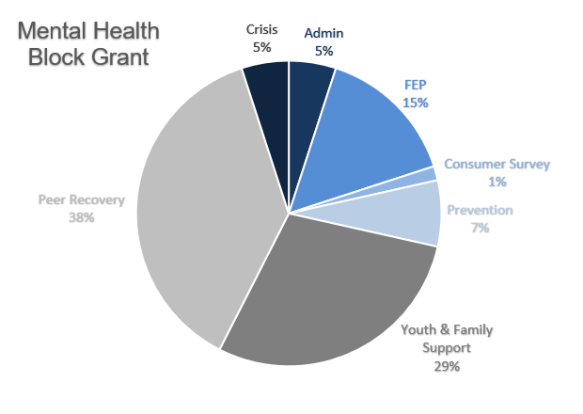

Link to the previous application that is posted on our website. You will see in the first paragraph that people are able to offer input and commentary on the application. This link does not expire as it has been serving as a continual opportunity for public feedback on the application. [https://www.maine.gov/dhhs/obh/about/grants](https://gcc02.safelinks.protection.outlook.com/?url=https%3A%2F%2Fwww.maine.gov%2Fdhhs%2Fobh%2Fabout%2Fgrants&data=05%7C01%7CSarah.Ferguson%40maine.gov%7Cdd1a29df04f24f1ddd7a08db81513438%7C413fa8ab207d4b629bcdea1a8f2f864e%7C0%7C0%7C638245958677554785%7CUnknown%7CTWFpbGZsb3d8eyJWIjoiMC4wLjAwMDAiLCJQIjoiV2luMzIiLCJBTiI6Ik1haWwiLCJXVCI6Mn0%3D%7C3000%7C%7C%7C&sdata=9o8RhTjwWCXNFobYNMVRNfoT7lujD%2F2E3OgcoQ2UEk0%3D&reserved=0)